**NAME AND SURNAME: Lethokuhle Ngobese**

**STUDENT NUMBER: ST10324870**

**MODULE NAME: PROGRAMMING 2B**

**MODULE CODE: PROG6212**

Documentation

**1.Documentation**

Database Structure

The Contract Monthly Claim System is made to effectively manage users (Admin, Managers, Lecturers), claims from Lecturers, and documents associated with those claims. There are 4 table UML table structures which is:

1. Lecture Table
2. Admin Table
3. Claims Table
4. Request Table
5. Monthly Report Table

The Tables are as follows:

Lecturer Table

Attributes: LecturerID, Name, Last Name, Email, Address

Rationale: This table captures lecturer information.

Admin Table

Attributes: AdminID, AdminName, Email

Rationale: Similar to the Lecturer table, this captures admin-specific details and maintains the inheritance structure.

Claim Table

Attributes: claimID, LecturerID, ClaimDate, Description

Rationale: This table obtains and stores all relevant information regarding claims.

Request Table

Attributes: RequestID, ClaimID, RequestDate

Rationale: This table shows all claims that were made by lecturers to be validated by admins.

Monthly Report Table

Attributes: ReportID, ClaimID, LecturerID,

Rationale: This table shows the reports of the claims that were previously made by lecturers.

2. GUI Layout

The GUI is designed with user experience in mind, focusing on simplicity and accessibility. Here’s an overview of the main components:

Main Window

Buttons: "Submit Claim", "Track Claim", "Admin Dashboard"

Rationale: The main window provides easy navigation to core functionalities. Buttons will be horizontally aligned with ample spacing and will be colored blue for visibility and aesthetics.

Submit Claim Control

Input Fields: Name, Surname, Employee ID, Contact Details, Address, Claim Type, Faculty, Module, Number of Hours, Hourly Rate, Total Amount, Document Upload

Rationale: This layout ensures that users can provide all necessary information in one form, making the submission process straightforward. The use of labels and text boxes aids in clarity.

Track Claim Control

Search Bar and DataGrid: Allows users to search for and view claims.

Rationale: A search feature improves usability, enabling users to quickly find specific claims. The DataGrid displays relevant claim details in an organized manner.

Admin Dashboard Control

DataGrid for Claims Management: Displays pending claims with options to approve or reject.

Rationale: This layout facilitates efficient claims management for administrators, allowing for quick decisions on claims.

3. Assumptions and Constraints

The users will have distinct roles (Lecturer and Admin) influencing their permissions and functionalities within the system.

The data integrity will be maintained, requiring proper validation at input stages to prevent errors (e.g., ensuring numerical fields contain valid numbers).

The document upload feature will handle various file types and sizes, requiring appropriate backend validation.

The design accommodates potential future enhancements, such as adding more user roles or additional claim types.

The structure is designed to ensure that querying the database remains efficient, even as the number of claims and documents grows.

**2. UML Class Diagram**

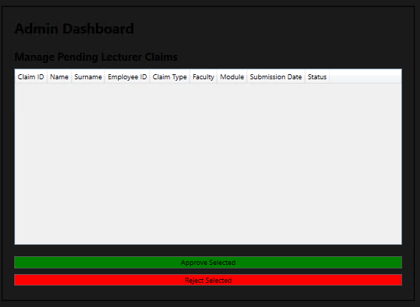

4. Project Overview

1.1 Project Name

Name: Contract Monthly Claim System Development

1.2 Project Description

Description: This project aims to develop a web-based application for managing monthly claims submitted by lecturers. The system will enable users to submit claims, track their status, and allow administrators to manage and approve claims efficiently.

1.3 Project Objectives

Objectives:

Develop a user-friendly interface for submitting and tracking claims.

Implement a secure authentication system for users and administrators.

Provide reporting capabilities for claim management and approvals.

1.4 Project Scope

User authentication and role management

Claim submission and tracking functionalities

Document upload and management

Admin dashboard for claims approval and reporting

1.5 Deliverables

Deliverables:

A functional web application for claim system

User and technical documentation

Test cases and testing results

1.6 Assumptions and Constraints

Assumptions:

Users have basic computer skills and internet access.

Stakeholders will provide timely feedback during development.

Constraints:

Project must be completed within a minimum of 45 hours.

2. Project Organization

2.1 Stakeholders

Stakeholders:

End Users: Lecturers and Administrative Staff

2.2 Project Team

Project Manager: ST10324870

Team Members:

Developer – Solo work – ST10324870

Designer – ST10324870

2.3 Roles and Responsibilities

Project Manager: Oversee project progress, manage resources.

Developer: Implement system features, perform coding and unit testing.

Designer: Design user interface and ensure usability.